**File:** **Kalin_Marinov_14_12_bce70c.rb**

Task:

#Develop a program named FirstName_LastName_ClassNumber_bce70c.rb

#

#1. you are given an argument for a folder with files;

#1.1 if there are other arguments they should be discarded

#2. file names in this folder are in the form First_Last_digits.rb;

#3. find all the students that have 5 letters in their second name;

#4. Sort the result by First name DESC.

#5. Produce a result in CSV format named result.csv:

#

# FirstName1,LastName1

# FirstName2,LastName2

# ...

# FirstNameN,LastNameN

Code:

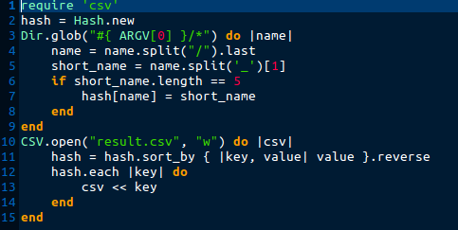

Errors:

* Wrong named source file
* In line 12: syntax error, unexpected keyword_do_block
* In line 15: syntax error, unexpected keyword_end, expecting $end
* File format check is missing
* Wrong input in hash file
* Wrong output from CSV
* Under line 4 we have need from variable for hash_key(In line 7 hash[name] is wrong)
* Result is sorted by last name

New code:

